**ERD Diagram for**

**Project: OUGLA**

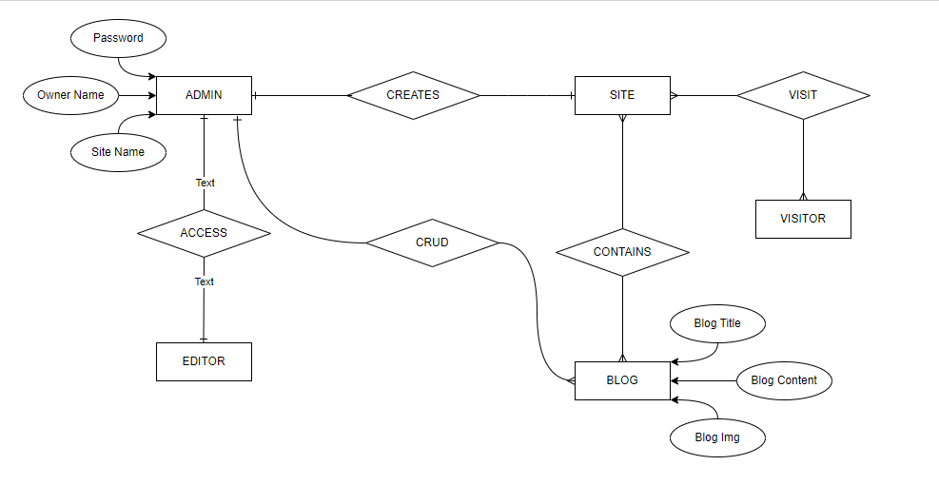

**DATA Flow Diagram for Project: OUGLA**

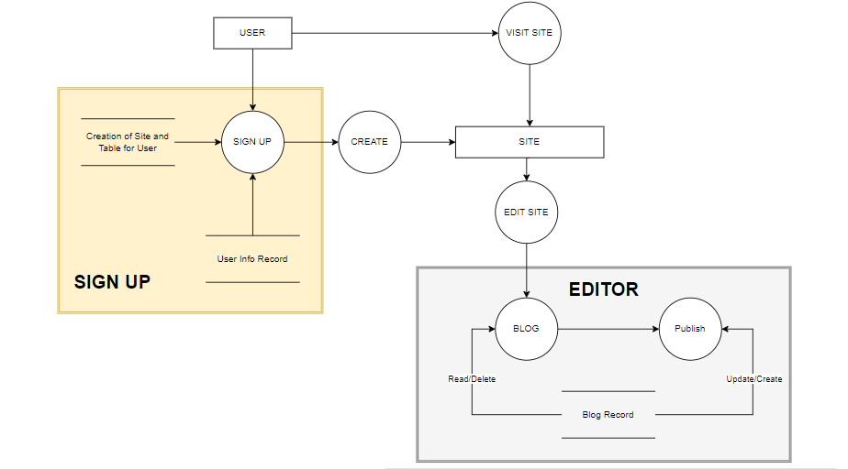

**USE-CASE Diagram for Project: OUGLA**

